INSTRUCTIONS: This is an SOP template; it is complete when
1) All form fields have been completed to reflect chemical/lab-specific information, including adding relevant procedure information, or deleted inapplicable information; and
2) SOP has been signed and dated by the PI and relevant lab personnel.
Use safety data sheets (SDSs) as a resource for chemical-specific information. Text highlighted in gray indicates where information should be added or edited. Delete all instructions in red text and “Draft” watermark after the SOP is approved by PI.
Review the Hydrofluoric Acid Focus Sheet on the EH&S website for additional information and guidance.
Standard Operating Procedure
Hydrofluoric Acid (HF)

Section 1 – Lab-Specific Information
Chemical(s) covered by this SOP:
Building/Room(s) covered by this SOP:
Unit or department:
Principal Investigator Name:
Principal Investigator Signature/Date:
Hydrofluoric acid CAS number: 7664-39-3
Important Definitions
- Acutely Toxic Material: Substances that may be fatal or cause damage to target organs as the result of a single exposure or exposure of short duration. Acute toxins are quantified by substance’s LD50 or LC50.
- Target Organ Toxic Material: Substances that pose adverse health effects to specific organs such as the liver, kidneys, lungs, etc.
Section 2 – Hazards
Hydrofluoric acid is very corrosive and destroys skin tissue even in dilute solutions. It readily penetrates skin to destroy tissues, decalcify bone and interfere with nerve function. Routes of exposure include skin/eye contact, inhalation, and ingestion. Target organs include skin, eyes, and lungs. Exposure to highly concentrated solutions can cause acute hypocalcemia (low level of calcium in the blood) followed by cardiac arrest and death. Exposure to eyes may result in permanent eye damage or blindness. It is highly toxic by inhalation, skin contact or ingestion. Exposure to concentrated HF can be fatal if the exposure covers over 2% of the body. Absorption of substantial amounts of HF by any exposure route may be fatal.
Skin contact with concentrated HF (48% or greater) causes immediate serious and painful tissue destruction. Contact with lower HF concentrations may not cause pain or other symptoms until several hours after contact. All contact or suspected contact with HF must be treated immediately.
REQUIRED - Describe any additional hazards associated with this/these chemicals
Obtain hazard information from SDS. Use GHS Pictograms to indicate hazards; delete the pictograms that do not apply.
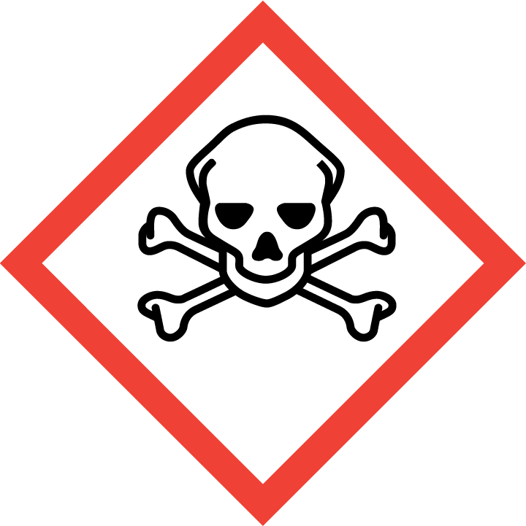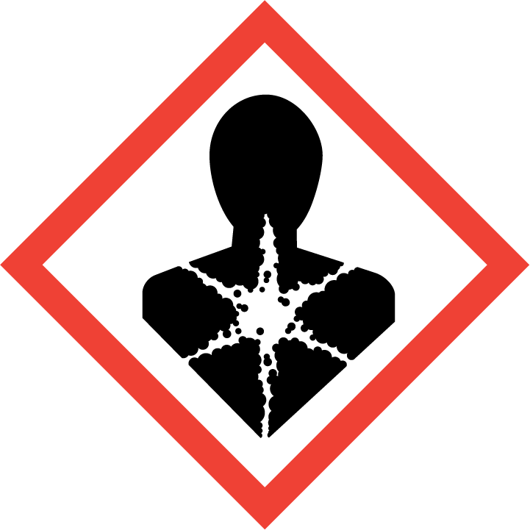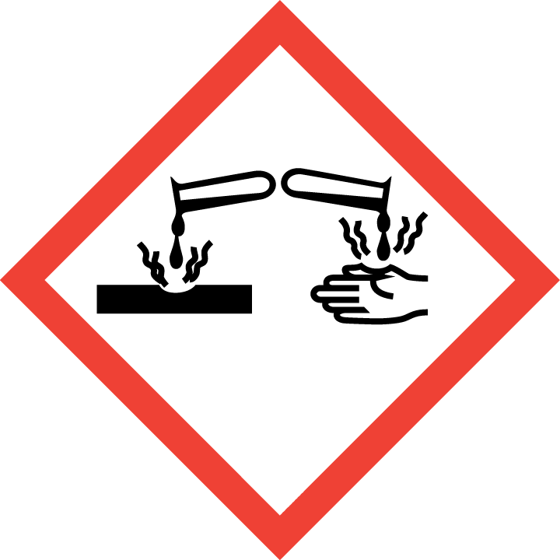

Section 3 – Engineering Controls and Personal Protective Equipment (PPE)
Using certain classes of chemicals, including particularly hazardous chemicals (i.e., highly toxic, reproductive toxicity, select toxins, carcinogens, corrosives, strong oxidizers, otherwise dangerous), under certain conditions (e.g., at elevated temperatures) may require facility-specific engineering/ventilation controls. Refer to the chemical SDS and identification of particularly hazardous substances in MyChem. Contact UW EH&S at labcheck@uw.edu for engineering control details.
Engineering Controls: Use of HF must be conducted in a properly functioning chemical fume. The chemical fume hood must be tested and passed by EH&S.
Restrict other activities in the fume hood while working with HF.
REQUIRED - Insert location of fume hood and any specific equipment safety features.
Hygiene Measures: Avoid contact with skin, eyes, and clothing. Wash hands after removing PPE, before breaks, and immediately after handling the chemical. If chemical comes into contact with any PPE, the PPE shall be immediately removed and discarded properly. See Section 5 for detailed instructions on exposure responses.
PPE must be specified completely, such as type, and whether necessary for the entire process or at certain steps. Refer to the chemical SDS(s) and UW Laboratory Safety Manual Section 5.b. for further guidance.
Skin and body protection. Chemically compatible laboratory coats that fully extend to the wrist must be worn and be appropriately sized for the individual and buttoned to their full length. Personnel must also wear full-length pants, or equivalent, and close-toe shoes. The area of skin between the shoe and ankle must not be exposed.
Impermeable chemical splash apron of rubber, neoprene or Viton, and Tyvek sleeve covers, or a Tyvek suit.
Laboratory coats will be disposed as hazardous waste if HF is spilled on them.
If a risk of fire exists, a flame-resistant laboratory coat that is NFPA 2112-compliant should be worn. Some FR fabrics (e.g., Nomex®, Rhovyl®, Kevlar®, etc.) are highly permeable and do not provide good chemical/acid resistance.
For chemicals that are corrosive and/or toxic by skin contact/absorption additional protective clothing (e.g.,face shield, chemically-resistant apron, disposable sleeves, etc.) are required where splashes or skin contact is foreseeable.
REQUIRED: Specify type of lab coats to be used (if multiple options are available) or list information on chemical-appropriate alternatives, such as chemical aprons.
Hand protection. Hand protection is required for the activities described in this SOP.
Chemical-resistant gloves must be worn. It is critical that the glove being worn is resistant to the particular chemical. Consult with your preferred glove manufacturer to ensure that the gloves you plan to use are compatible with the specific chemical being used.
Recommend 6 mil nitrile inner gloves and 22 mil (nominal) gauge neoprene or butyl rubber gloves or SilverShield outer gloves. Nitrile gloves (6 mil) may also be used as a layer on top of SilverShield gloves for dexterity. Do not use latex gloves.
REQUIRED – Specify gloves or combination of gloves that are required. When possible, include the exact manufacturer and model information.
Gloves must be inspected prior to use, including a check for pinholes.
Gloves will be disposed after each use and changed immediately if contaminated, torn, or punctured.
Use proper glove removal technique (without touching glove’s outer surface) to avoid skin contact with this product. Dispose of contaminated gloves after use in accordance with applicable laws and good laboratory practices. Wash and dry hands immediately after glove removal.
Eye protection. ANSI Z87.1-compliant eye protection is required for all work with these chemicals. Wear Safety goggles with a face shield.
REQUIRED - Specify minimum eye protection required (splash goggles, safety glasses, safety goggles, face shields).
Respiratory protection. Respiratory protection may be needed if aerosol or vapor hazard is present and work is conducted outside of a fume hood.
If Hydrofluoric Acid is being used outside of a chemical fume hood, respiratory protection is/is not required for the activities described in this SOP.
REQUIRED - Specify if/when this chemical is allowed to be used outside of a fume hood and if additional respiratory protection is required for such work. Include expectations for completion of respirator fit-testing.
Respirators should be used as a last line of defense (i.e., after engineering and administrative controls have been exhausted), and when any Action Limit (AL) or Occupational Exposure Limit (OEL) has been exceeded or when there is a possibility that an AL/OEL will be exceeded. Respiratory protection may be needed if a dust, aerosol or vapor hazard is present and work is conducted outside of the fume hood. If any procedure may pose an external hazard, it should be eliminated or strictly isolated.
If a potential exposure hazard cannot be eliminated, contact the EH&S Respiratory Protection Program administrator at uwresp@uw.edu, or call 206.543.7388 to discuss respiratory protection or to enroll in the program so a respiratory protection analysis can be performed. Program enrollment includes medical evaluation, training and fit testing for an appropriate respirator. Where air-purifying respirators are appropriate, use a full-face respirator with appropriate respirator cartridges as a backup to engineering controls. Use a full-face supplied air respirator if it is the sole means of protection.
Section 4 – Special Handling and Storage Requirements
REQUIRED - Insert descriptions of any additional administrative controls (e.g., restrictions on procedure/quantity/work equipment/work locations/unattended operations/etc.), including controls that may be chemical-specific (e.g., peroxide formers). Specify limits, if any, to the amount of chemicals/reactants during process.
Specify practices beyond general laboratory rules that are required for the chemical(s).
Identify best practices used to minimize accidents (temporary hazard signs when personnel are absent, etc.)
Describe special storage requirements: Secondary containment? Locked cabinet? Incompatible chemical groups? Container type(s); special precautions.
Describe transport requirements.
- Purchase the smallest amount of HF feasible for specific tasks, or purchase HF diluted to the concentration for use.
- Ensure personnel working with HF and any other personnel authorized or required to be in the laboratory or shared space during work with HF have completed Hydrofluoric Acid training.
- Ensure spill kit an first aid supplies specified in Section 5 are available in the laboratory prior to work starting.
- Confirm emergency eyewash and/or shower are located within HF working area and have a current certification date.
- For use, transport HF from the storage area to the fume hood in a labeled, sealed non-breakable secondary container. Always remove HF from its secondary container in a fume hood in order to safely vent any accumulated vapor.
- All preparation of HF will be performed over plastic-backed absorbent pads in a fume hood. Pads will be disposed of as hazardous waste immediately upon contamination and after completion of tasks.
- Ensure compatibility of HF before mixing with other chemicals or disposing of it in a hazardous waste container. Review the SDS for incompatibilities. HF reacts with some metals and liberates flammable hydrogen gas.
- Label all aliquots and solutions clearly with the original manufacturer’s label, which should have the chemical name, hazard labels, and pictograms. The label should not be defaced in any way.
- Keep containers tightly closed. Store in a cool, dry, and well-ventilated area away from incompatible substances such as strong acids.
- Clean the fume hood upon completion of tasks with a 10% calcium carbonate solution, followed by soap and water.
- Clean all contaminated surfaces with a 10% calcium carbonate solution, followed by soap and water.
- Place all contaminated disposable items in appropriate laboratory waste for disposal.
- Non-disposable/re-usable utensils, containers, and other surfaces contaminated with HF must be decontaminated using a 10% calcium carbonate solution, followed by soap and water, at the end of the laboratory work session. Complete this inside the fume hood before removing any of the items.
- HF will be stored in an acid cabinet in REQUIRED - Specify location
- Do not store with organic acids, ammonia or other alkaline chemicals. Store on lower shelf.
- Keep away from heat, light, air, flames and sources of ignition.
- Never store or work with HF in incompatible containers of glass, metal or ceramic.
- Store HF in labeled, sealed, non-breakable secondary compatible (plastic or Teflon) container within storage area, if potential for disturbance or breakage exists.
- HF will be transported in labeled and sealed non-breakable secondary container.
- When work is completed, remove gloves and wash hands with soap and water.
Users of chemicals are required to follow labeling requirements when transferring chemicals to secondary containers and when labeling containers with chemical waste, UW-synthesized chemicals, and Chemicals of Interest. Requirements for labeling containers and templates for creating labels are available on the EH&S website.
Check Section 2 of the Lab Safety Manual and the Chemical Compatibility Chart on the EH&S website for incompatible chemical groups.
Special storage precautions may include keeping away from heat, light, air, flames, and sources of ignition.
Check Section 2 of the Lab Safety Manual for information on chemical transport practices.
Section 5 – Spill and Accident Procedures
REQUIRED - Insert descriptions of any specialized spill clean up procedures for materials used in this SOP, including the procedures for corrosive spill cleanup. Additional details of lab-specific spill cleanup should be provided if applicable.
Spill response procedures must be developed based on the chemical and potential spill or release conditions.
- Spill response procedures must be developed based on the chemical (refer to SDS) and potential spill or release conditions and using the appropriate spill kit.
- Differentiate small vs. large spills, spills in hood vs. outside of hood. Note quantities and concentrations specific for this/these chemical(s).
- Differentiate liquid vs. powder spills: materials and procedures.
- Include appropriate/additional PPE required for spill cleanup. For chemicals that are corrosive and/or toxic by skin contact/absorption, additional protective clothing (e.g., face shield, chemically-resistant apron, disposable sleeves, etc.) are required where splashes or skin contact is foreseeable.
- Determine whether/when EH&S must be contacted: Typically the chemical, conditions, and size of spill will be deciding factors. If in doubt, contact EH&S.
Do not attempt to clean up any spill if not trained or comfortable. Chemical spills must be cleaned up as soon as possible by properly protected and trained personnel. All other persons should leave the area. Spill response procedures must be developed based on the chemical and potential spill or release conditions. Clean up spills using contents of the laboratory spill kit.
If trained and equipped, only clean up small (less than 100 ml) and dilute (less than 1%) spills that occur in a fume hood. If the spill is larger or more concentrated or people have been exposed, evacuate the area and call 9-1-1.
If a person is exposed follow EXPOSURE PROCEDURES outlined below.
For questions on spill cleanup, contact EH&S spill consultants at 206‐543‐0467 during normal business hours (Monday-Friday, 8 a.m. to 5 p.m.). After hours call 9-1-1 on a campus phone for help.

SPILL CLEANUP PROCEDURES
Small spills (less than 100 ml) of dilute HF (less than 1%) inside fume hood
- Close hood sash, cordon off area.
- If you need help, call EH&S during normal business hours or call 9-1-1 outside business hours. Tell them that a Hydrofluoric Acid spill has occurred and you need advice or assistance. Notify supervisor.
- Personnel must wear a lab coat with rubber, neoprene or Viton apron/Tyvek sleeve covers or a Tyvek suit, safety goggles and face shield. Wear 6 mil nitrile inner gloves and 22 mil (nominal) gauge neoprene or butyl rubber gloves or SilverShield outer gloves. Optional to use nitrile gloves as a layer on top of SilverShield gloves for dexterity.
- Wipe up spilled liquids with absorbent pads.
- Clean the spill area thoroughly with a 10% calcium carbonate solution, followed by soap and water. Dry.
Do not attempt to neutralize HF with the following because of potential adverse reactions: sodium or potassium carbonate, potassium or sodium hydroxide, silicon-based absorbent materials such as sand, vermiculite or kitty litter.
- If spill is extensive within the containment, clean all interior surfaces after completion of the spill cleanup.
- Double bag all waste in plastic bags labeled as HF spill debris and store in fume hood away from incompatible chemicals or procedures. Submit request to EH&S for hazardous waste pickup.

All other spills including:
- Spills greater than 100 ml in size
- Spills greater than 1% in concentration
- Any spill of HF outside of fume hood regardless of concentration
- Evacuate all personnel from the laboratory and restrict access. Call 9-1-1.
- As soon as possible report the spill by notifying EH&S during normal business hours or call 9-1-1; tell them that a spill has occurred, and that you need help managing the spill. EH&S will contact a spill cleanup contractor. Notify supervisor.
- Be prepared to provide the following information:
- Name and phone number of knowledgeable person that can be contacted
- Name of chemical spilled, concentration and amount spilled, liquid or solid type spill
- Number of injured, if any (refer below to EXPOSURE PROCEDURES)
- Location of spill
Describe how spills or accidental releases should be handled and by whom.
Clean up spills using contents of the laboratory spill kit: [describe specific types of spill clean-up materials required].
Specify any signage, entry restrictions that are required.
Describe PPE required for cleanup.
Any spill, exposure or near miss incident requires the involved person or supervisor to complete and submit the Online Accident Reporting System (OARS) form on the EH&S website within 24 hours (certain types of incidents require immediate notification) at oars.ehs.washington.edu.
Exposures: If a person is injured, exposed, or suspected of being exposed to Hydrofluoric Acid, follow procedures listed here:
INSERT IF APPLICABLE - Descriptions of any specialized emergency procedures for locations outside of a UW campus or facility.
Perform first aid immediately.
Refer to SDS for additional chemical-specific guidance; include pertinent information here.
- Inhalation exposure: Move out of contaminated area; Call 9-1-1 and get medical help.
- Sharps injury (needle stick or subcutaneous exposure): Call 9-1-1. If calcium gluconate gel is available, use the nearest safety shower for 5 minutes. Stay under the shower and remove clothing. Use a clean lab coat or spare clothing for cover-up. With gloved hands, apply calcium gluconate gel to the skin liberally and massage it into the affected site. Apply the gel as soon as the washing is done. Affected area does not need to be dried prior to application. Reapply gel continually every 10-15 minutes and massage into the skin until medical treatment is given. If calcium gluconate gel is not available, continue flushing with water for at least 15 minutes or until medical treatment is given.
- Skin exposure: Call 9-1-1. If calcium gluconate gel is available, use the nearest safety shower for 5 minutes. Stay under the shower and remove clothing. Use a clean lab coat or spare clothing for cover-up. With gloved hands, apply calcium gluconate gel to the skin liberally and massage it into the affected site. Apply the gel as soon as the washing is done. Affected area does not need to be dried prior to application. Reapply gel continually every 10-15 minutes and massage into the skin until medical treatment is given. If calcium gluconate gel is not available, continue flushing with water for at least 15 minutes or until medical treatment is given.
- Eye exposure: Call 9-1-1. If sterile 1% calcium gluconate emergency eyewash solution is available, use the nearest safety eyewash for 5 minutes while holding eyelids open. Then apply the calcium gluconate solution as a continuous drip into eyes (do NOT apply calcium gluconate GEL to eyes). If sterile 1% calcium gluconate solution is not available, use the safety eyewash for at least 15 minutes or until medical treatment is given.
Get Help.
- Call 9-1-1 or go to nearest Emergency Department (ED); provide details of exposure:
    - Chemical name and concentration
    - Dose
    - Route of exposure
    - Time since exposure
- Bring the SDS for the specific chemical and this SOP to the Emergency Department
- Notify your supervisor as soon as possible for assistance
- Secure the area before leaving; lock doors and indicate spill if needed
Report the incident to Environmental Health & Safety.
- Notify EH&S immediately after providing first aid and/or getting help.
  - During business hours (M‐F/8‐5), call 206‐543‐7262.
  - Outside of business hours, call 206‐685‐UWPD (8973) to be routed to EH&S Staff On Call.
- The involved person or supervisor submits the UW Online Accident Reporting System (OARS) form on the EH&S website within 24 hours (certain types of incidents require immediate notification) at oars.ehs.washington.edu.
Refer to SDS for additional chemical-specific guidance; include pertinent information here.
Section 6 – Waste Disposal Procedures
Waste bottles of concentrated or dilute solutions of HF must be collected by EH&S as a hazardous waste.
Waste containing hydrofluoric acid is considered a hazardous chemical waste.
Double bag all used and contaminated (not grossly contaminated) disposable items, such as gloves, paper towels and absorbent pads, in plastic bags. Label as non-hazardous waste before disposing in the trash.
Place grossly contaminated disposable items in double plastic bags for hazardous waste pickup.
REQUIRED - Describe specific waste disposal procedures for all waste streams generated with this/these chemical(s). Include appropriate containment practices, storage locations, and any specific storage or handling practices. If relevant, include instructions for updating chemical inventories.
Refer to the SDS and UW Laboratory Safety Manual, Section 3 for guidance on waste handling, labeling, accumulation, storage and pickup.
Per UW Administrative Policy Statement 11.2, the University of Washington Environmental Health & Safety Department has full responsibility for collection of hazardous waste for the University, all its campuses, and off-site locations; University laboratories cannot contract with an outside vendor to collect hazardous waste.
Be aware that many laboratory accidents happen from inadvertent disposal of incompatible wastes into the same waste container. Therefore, identify different waste streams as appropriate.
Accumulate waste at the point of generation in a sturdy, [compatible container], with a securely-closable/screw‐top lid.
Vented lids may be appropriate for certain chemicals. Email labcheck@uw.edu with questions.
Manage chemical and hazardous chemical waste separately from other waste streams such as biohazardous waste. Never autoclave chemical waste because it can produce hazardous chemical vapors, aerosols, and explosive reactions.
Chemical treatment and recycling and chemical exchange options and are available on the EH&S website.
All chemical waste containers must be labeled with a UW Hazardous Waste Label. Refer to How to Label Chemical Waste Containers on the Chemical Waste Disposal webpage on the EH&S website.
To request a collection of chemical waste, submit a form on the Chemical Waste Disposal webpage on the EH&S website or directly in MyChem inventory. Contact EH&S at 206.616.5835 or chmwaste@uw.edu with questions.
Work area decontamination procedures as appropriate for the chemical in use should be followed.
REQUIRED - Insert descriptions of decontamination procedures for equipment, glassware, and controlled areas (e.g., glove boxes, restricted access hoods, perchloric/hot acid fume hoods, or designated portions of the laboratory) where this/these chemical(s) is/are used.
Visit the Hazardous Material Disposal and Recycling webpage on the EH&S website for information on disposing, recycling and surplusing materials.
Section 7 – Protocol/Procedure (Additional lab protocol may be added here)
REQUIRED - Insert or attach detailed laboratory-specific procedures for the process, hazardous chemical(s), or hazard class. You may also include any relevant supporting resources such as journal citations, etc. that are applicable.
Refer to Section 2 of the UW Laboratory Safety Manual on the EH&S website for additional guidance on chemical management and preparation for use for particularly hazardous substances (PHSs).
NOTE: Any deviation from this SOP requires approval from Principal Investigator.

Section 8 – Special Precautions for animal use (_X_Yes ___No)
Use of [HF-containing chemical], in animals will be documented and approved by IACUC.
Annotate “N/A” if no animal exposure is involved. If chemicals are being administered to animals, describe how employees should protect themselves from contaminated animals and animal waste below. Include all restricted access, chemical administration, aerosol suppression, PPE, and waste disposal procedures required.
Describe how employees should protect themselves from contaminated animals and animal waste.
PARTICULARLY HAZARDOUS SUBSTANCE INVOLVED?
YES: Sections #9 to #11 are Mandatory.
EH&S flags Particularly Hazardous Chemicals in MyChem based on hazards.

Section 9 – Approvals required
All staff working with [HF-containing chemical] must complete EH&S’s Hydrofluoric Acid training prior to starting work.
All staff working with [HF-containing chemical] must be trained on this SOP prior to starting work. They must also review the [HF-containing chemical] SDS, and it must be readily available in the laboratory. All training must be documented and maintained by the PI or their designee.
Describe any requirements for obtaining authorization before use of the chemical for the procedure, operation, or activity can be performed.
Examples:
- A worker must have [specific training] documented before performing described procedure for the first time.
- A medical examination must be completed prior to respirator use (for lead, dust, pathological organisms).
- Other authorizations required before a person can independently perform a process using a particularly hazardous substance.

Section 10 – Decontamination
Include work area decontamination procedures as appropriate for the chemical in use:
REQUIRED - Insert descriptions of decontamination procedures for equipment, glassware, controlled areas (e.g., glove boxes, restricted access hoods, perchloric/hot acid fume hoods, designated laboratory areas), include cleaning solutions and materials.

Section 11 – Designated area

REQUIRED - Identify specific areas where the particularly hazardous chemicals may be used (e.g., glove boxes, restricted access hoods, perchloric/hot acid fume hoods, or designated portions of the laboratory).

Section 12 – Documentation of training (signature of all users is required)
- Prior to using substances included in this SOP, laboratory personnel must be trained on the hazards described in this SOP, how to protect themselves from the hazards, and emergency procedures.
- Ready access to this SOP and to a Safety Data Sheet for each hazardous material described in the SOP must be made available in the lab space(s) where these substances are used.
- The Principal Investigator (PI), or Responsible Party, if the activity does not involve a PI, must ensure that their laboratory personnel have attended appropriate laboratory safety training (and refresher training where applicable).
- Training must be repeated following any revision to the content of this SOP.
- Training must be documented. This training sheet is provided as one option; other forms of training documentation (including electronic) are acceptable but records must be accessible and immediately available upon request.
I have read and understand the content of this SOP:

Name | Signature | Date

